**Task1: (In lab Task)**

|  |
| --- |
| **• As a Root use Ubuntu OS terminal to do the following:**  **E:\0School\Second Year\Semester 1\Linux\Assignments\Linux_Ass_2\TASK1\1.png1. Create all the given users and add them to their groups.**  **E:\0School\Second Year\Semester 1\Linux\Assignments\Linux_Ass_2\TASK1\2.png2. Use both head and tail Commands to show only one user information in your system.**  **E:\0School\Second Year\Semester 1\Linux\Assignments\Linux_Ass_2\TASK1\3.png3. Apply all users’ access permissions on the file ICTcompany.txt.**  **4. Change Nada login name to be Salma with the same Salary.**  **E:\0School\Second Year\Semester 1\Linux\Assignments\Linux_Ass_2\TASK1\4.png**  **E:\0School\Second Year\Semester 1\Linux\Assignments\Linux_Ass_2\TASK1\5.png5. Remove Omnia from programmer group.**  **6. Add Sarah to programmer group as a Senior with Salary 7000.**  **E:\0School\Second Year\Semester 1\Linux\Assignments\Linux_Ass_2\TASK1\6.png**  **E:\0School\Second Year\Semester 1\Linux\Assignments\Linux_Ass_2\TASK1\7_1.pngE:\0School\Second Year\Semester 1\Linux\Assignments\Linux_Ass_2\TASK1\7_2.png7. Change Ayman access permissions on the file ICTcompany.txt to be like TeamLeader access permissions and login with Ayman to change the Adam Salary to be 5000 is that works and why? (Analyze the reasons based on access permissions and file ownership).**  **It works**   * **Ownership:** Every file and directory belongs to a specific user and group, determining who has default access rights. * Owner: The user who created the file or directory. * Group: A set of users with shared access rights. * **Permissions**: Define what actions can be performed on a file or directory by different users. * Read (r): Allow viewing contents of a file or listing contents of a directory. * Write (w): Allow modifying contents of a file or adding/removing files within a directory. * Execute (x): Allow running a file as a program or entering a directory. |

**Task1: (In lab Task)**

**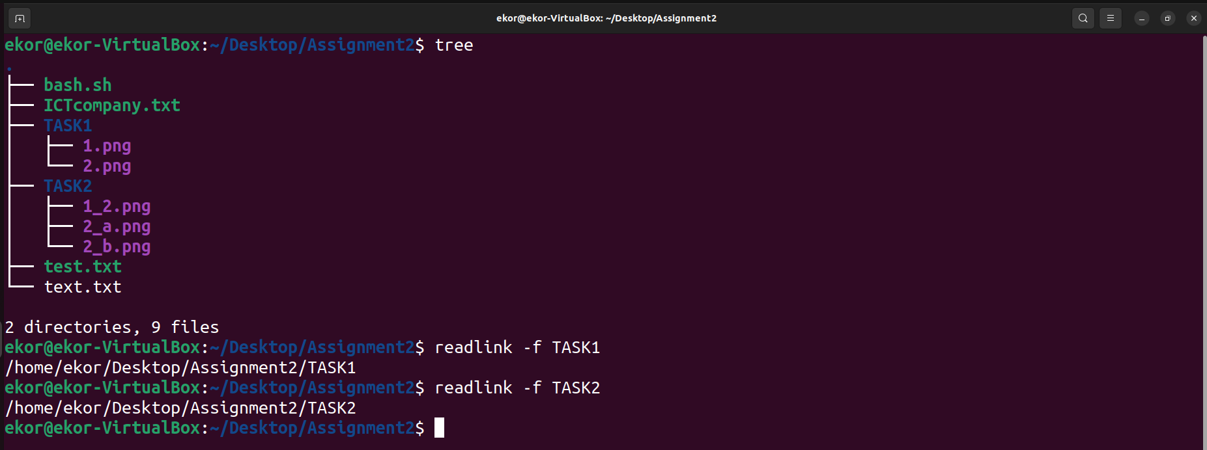1. From your exploration of the directory tree in your Linux operating Systems. Sketch the directory tree and mention the direct path of each directory. Then, give the function of at least three system directories.**

**/bin:**

* Binary or executable programs.
* Booting the system.
* Running core commands in the root filesystem.

**/etc:**

* System configuration file.
* Serves as the central repository for system-wide configuration files.
* These files define settings and options that control the behavior of various programs and services, shaping the system's overall functionality.

**/boot:**

* It contains all the boot-related information files and folders such as conf, grub, etc.
* Houses essential files required for the system to boot successfully.
* It's like a launchpad that provides the bootloader with the necessary tools to initiate the startup process.

**2. Based on the given scenario, Use ICTcompany.txt do the following:**

**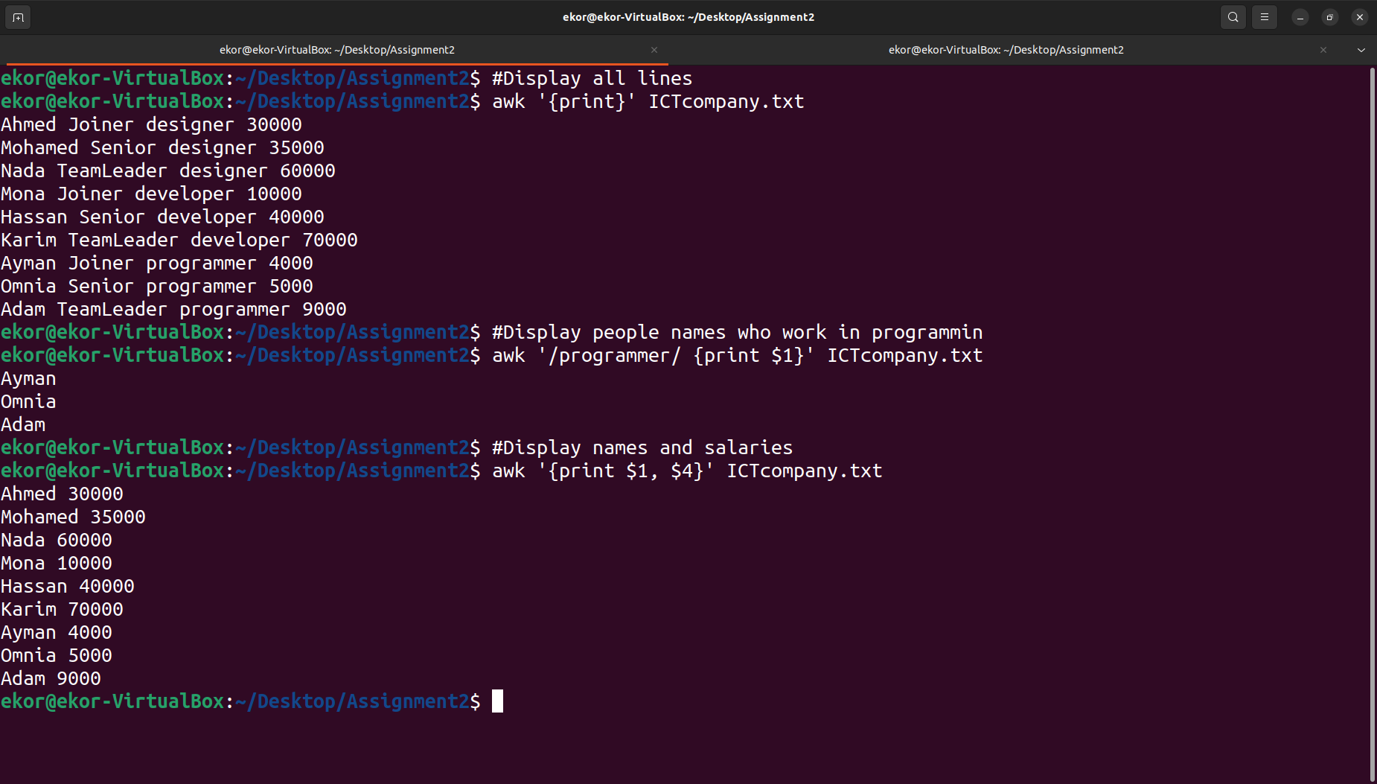a. Use AWK Command with different options and arguments to print the output of some organized data in three different examples.**

**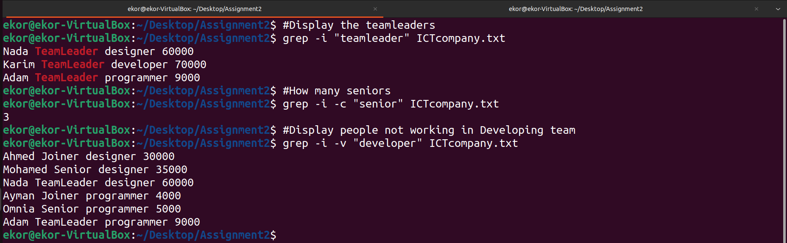b. Use Grep command with different options and arguments toprint the output of some organized data searched data in three different examples.**

**c. Analyze how the users and groups information stored on Linux based on the given ICTcompany.txt file.**

**/etc/psswd**

Users’ information stored in /etc/passwd file, this file stores user essential information: username, password (encrypted), user ID, group ID, Home directly, default shell. Respectively.

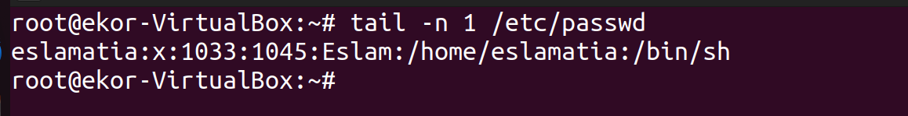

**/etc/shadow**

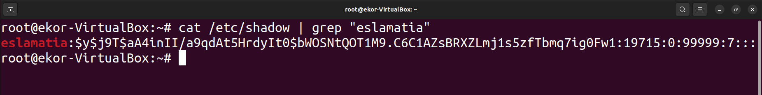Passwords securely stored encrypted along with information like expiration and last date change, and account login status

**/etc/group**

Defines groups and their members, and some information like: Group name, Group ID, List of group members



**d. Analyze users and groups’ access permissions and file ownership for the given ICTcompany.txt file.**

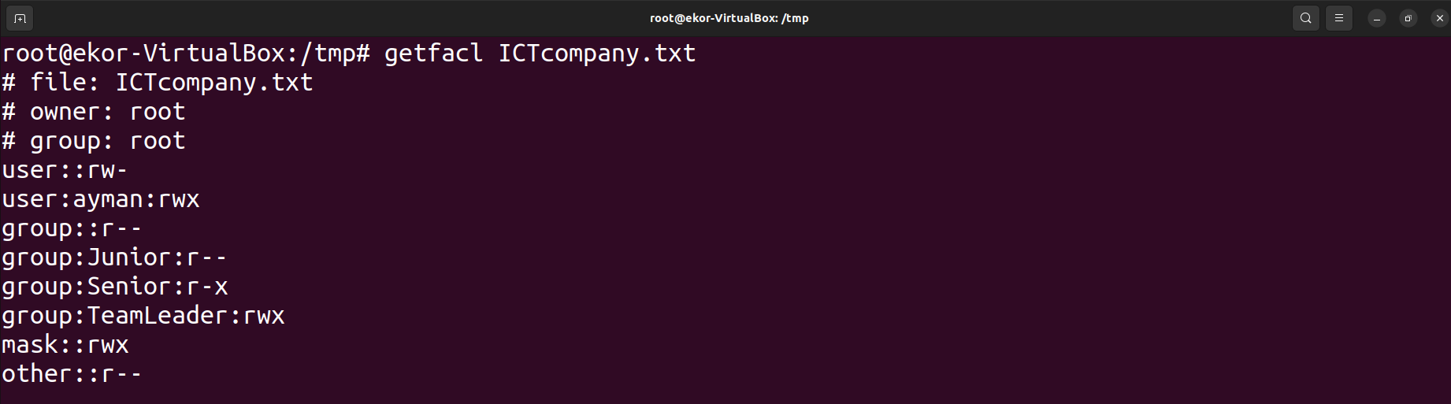

The owner of the ICTcompany.txt file is root, that’s because when I created this file is was in root mode.

The Junior Group has the access to just read the file, while the Senior Group has the access to read and execute, finally the TeamLeader Group has the access to read, write and execute. Anyone else has the permission to just read the file.

Ayman has the permission to read, write and execute while he is in Junior Group; because I changed his permission in order of one of the questions.

\_\_\_\_\_\_\_\_\_\_\_\_\_\_\_\_\_\_\_\_\_\_\_\_\_\_\_\_\_\_\_\_\_\_\_\_\_\_\_\_\_\_\_\_\_\_\_\_\_\_\_\_\_\_\_\_\_\_\_\_\_\_\_\_\_\_\_

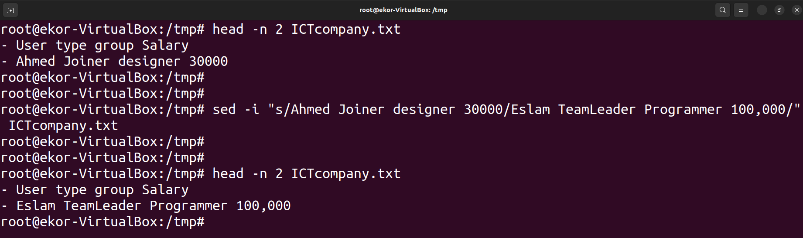

In the previous pic, I modified in ICTcompany.txt without opening the file, using the **sed** command.